Fi

**University of Nevada Las Vegas**

**Department of Electrical and Computer Engineering**

**EE498 Senior Design**

Spring 2018

**Fiber Optic Sensor for CubeSat**

Final Project Report

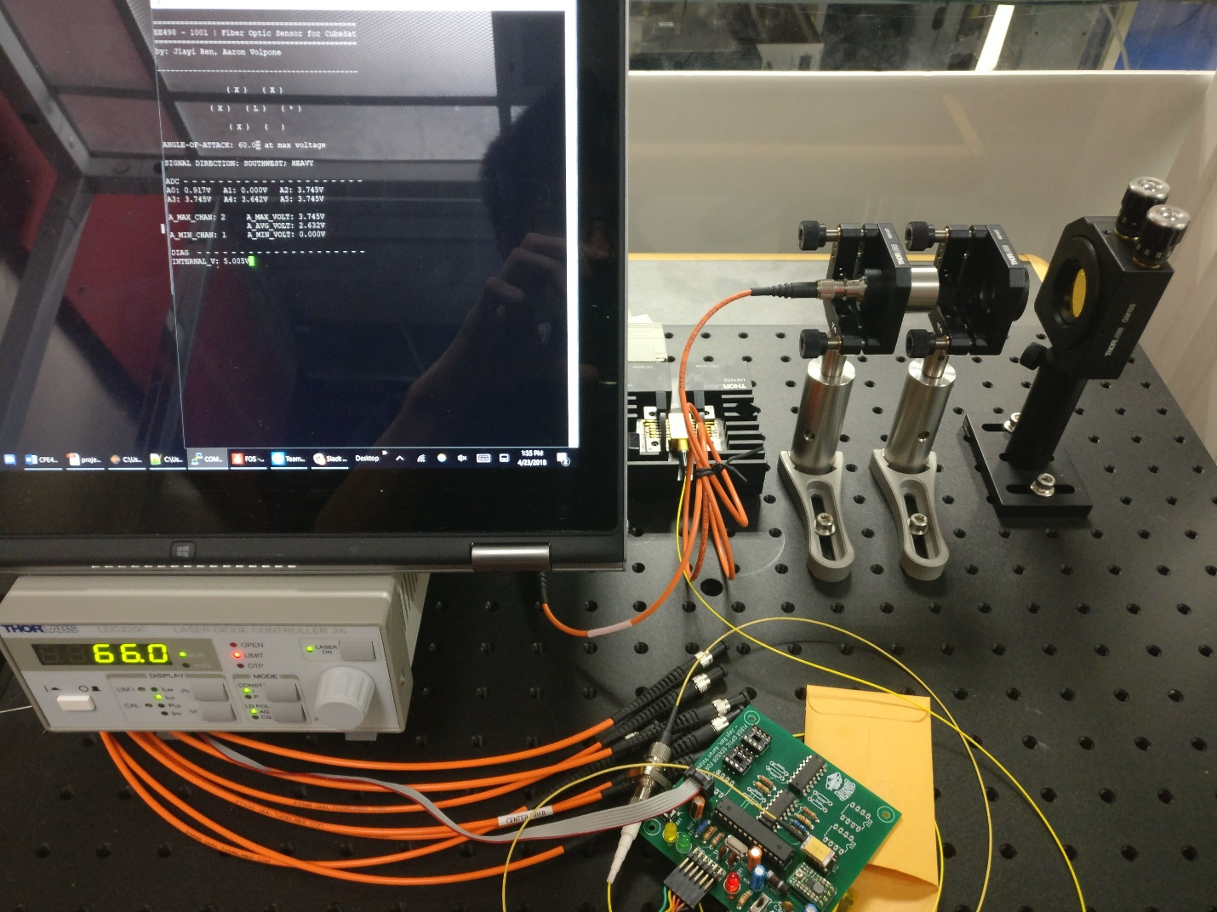

**Group Members:**

|  |  |  |  |
| --- | --- | --- | --- |
| Jiayi Ren |  | EE |  |
| Name (Print) |  | CPE/EE/ME |  |
| Aaron Volpone |  | CPE |  |
| Name (Print) |  | CPE/EE/ME |  |

Instructor: Dr. Grzegorz Chmaj

Faculty advisor: Dr. Ke-Xun Sun

Table of Contents

Abstract 3

Introduction 3

Current Market Solutions 4

Research Results 5

Angular Displacement 5

Fiber Optics 5

Specification of the project 7

Functionality & conceptual design: 7

Architecture: 9

Design 14

Simulation 19

Testing 20

User's manual 21

How to Setup 21

How to Connect 21

User Instructions 21

Roles & skills in the project 22

Parts list 23

Project timeline 28

Encountered Issues 30

Hardware 30

Software 30

Planned Improvements 31

Incomplete 31

Future work 32

Final Remarks 33

References 34

# Abstract

The Fiber Optic Sensor for CubeSat is a sensor module designed by students to be implemented for future use in UNLV’s CubeSat project. Compared to conventional angular sensors such as gyroscopes, this CubeSat fiber optic sensor boasts higher reliability and precision for data computations than current commercial solutions. Fiber optic sensors do not use moving parts. As a result, longevity of the sensor is ensured for flight missions. This is important to consider in the setting of space where repairs are not an option once a satellite is deployed. Ultimately, the fiber optic sensor accomplishes the challenge of angular correction and alignment in space where user-controlled steering would be delayed and error-prone.

# Introduction

The advent of **CubeSats** have enabled universities and space agencies alike to conduct research at much lower financial costs than conventional, bulky satellites CubeSats, on the other hand, boast notable features:

* + 10cm3 volume, weighting 1.33kg per unit (U)
  + Modular and miniaturized, can be built in several unit sizes: 1U, 2U, 3U+
  + Affordable, with the average launch price being around $40,000

Schools (along with private organizations) have taken interest in designing CubeSats due to their affordability and accessibility. As a result, they have become good tools for education related to various fields of engineering and sciences.

The Fiber Optic Sensor for CubeSat demonstrated a challenging relationship between the complexity of optical equipment and its price. Though the equipment present during this project can measure angular displacement, the size of its future implementation is not possible given the constraints of a CubeSat. Thus, several considerations need to be taken to reach a grander consolidation of equipment for the future of UNLV’s CubeSat project:

* Understanding of the relationship between minimization and growing costs. These need to be considered with the limited budget given with undergraduate senior design.
* Ensuring the continued multidisciplinary capabilities of future teams for projects. As CubeSat development continues, the facets of various member specializations begin to converge.
* Continuation of exposure to future students and the potential to carry these projects into graduate research.

The benefit of working through a long-term project is enabling the ability for future teams to pick up a on an established foundation.

The purposes of Fiber Optic Sensor for CubeSat are following:

* Design a displacement sensor board for use in a future UNLV CubeSat project.
* Use fiber optics in replacement of traditional integrated chip designs for the board.
* Use near-infrared (NIR) photodiodes to detect and interpret a laser input for displacement.
* Demonstrate the implementation of an optical setup used to drive a laser and receive its input across mounted photodiodes.

# Current Market Solutions

The field of small group satellite engineering is both incredibly expensive and time consuming. UNLV’s CubeSat project will not just be a single year development, but rather a ten year or greater roadmap. As a result, total pricing is currently unknown as payload items and goal changes are not capable of being known at this time.

|  |  |  |  |  |  |  |
| --- | --- | --- | --- | --- | --- | --- |
|  | **Vendor** | **Accessibility** | **Creative Constraints** |  | **Price** | **Comment** |
| **Government**  **CubeSat** | NASA | Government work | ? |  | ? | Requires access to government facilities |
| **Commercial CubeSat** | Clyde Space / CubeSat Shop | Commercial | Yes | $50k to $250k | Needs to be ordered and manufactured by vendor, high cost due to premade parts |
| **UNLV CubeSat** | UNLV | Academic / Commercial | No, self-designed equipment | TBD | Developed parts at UNLV, support from NASA |

Table 1. Comparison of available devices

The field of microprocessors in CubeSat devices remain limited in application. This is because of two factors: limited power requirements and experience in space application currently. As a result, it is either recommended to use processors that have already be tried successfully in the past or attempt to use similar low-power embedded solutions.

|  |  |  |  |  |  |  |
| --- | --- | --- | --- | --- | --- | --- |
|  | **Processing Power** | **Power Drain** | **Price** | **…** | **Strengths** | **Weaknesses** |
| **Home MC / DSP** | Medium to High | Medium | Varies |  | * Fast processing power * Often multi-cored | * High price * High power drain |
| **Ultra-Low Power MSP** | Low to Medium | Minuscule | Varies |  | * High resolution * Low price | * Medium battery life |

Table 2. Strengths and weaknesses of available devices

# Research Results

## Angular Displacement

Measurement of **angular** **displacement** is to determine at what degree an object is facing toward a relative point-of-reference. In this case, the point of reference is a neighboring CubeSatin space. Adjustments in alignment are to be done until CubeSats face each other.

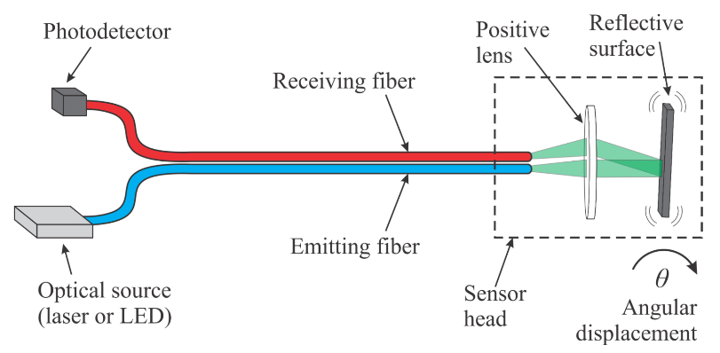

The operation of Fiber Optic Sensor for CubeSat is based on the modulation of the intensity of light by the angular displacement (reflective surface angle, θ). As the angular displacement alters, the intensity of corresponding fiber changes. Based on the voltage received by the amplifier, it could be later determined what angular displacement is.

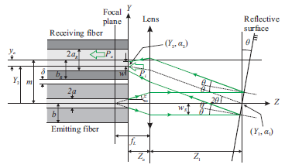

## Fiber Optics

Fiber optic cables carry light instead of electricity. Through this simple trait, they provide several advantages in the field of data transmission and sensing over conventional copper wire communications. Some primary features of fiber optics are as following:

* Longer distance transmission – fiber optics benefit from minimal power loss, meaning they can be transmitted over great distances.
* High bandwidth capability – the volume of data that fiber optics can transmit per unit of time is far greater than copper wire.
* No moving parts – moving items create wear and can fail. In the realm of space, repairs are a nearly impossible (even unnecessary) task.
* Resistance to electromagnetic interference – fiber optic cables are not prone to radio interference caused by electrical circuitry.
* Multiple uses *–* various forms of optical data can be transmitted back-and-forth across a fiber cable.

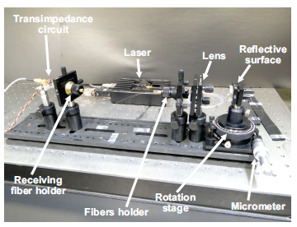A similar fiber optic angular displacement laboratory setup is shown below.

# Specification of the project

## Functionality & conceptual design:

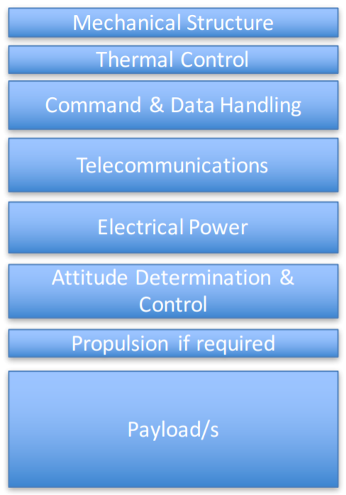In the grand scheme of CubeSat operation, the fiber optic sensor serves a very specific purpose. It is modular and capable of being used in tandem with other sensors.

Displayed in Figure 3 are the various fields of operation that a CubeSat needs to function. The fiber optic sensor falls under the category of attitude determination and control. This module serves to control the satellite that the sensor is installed in - this becomes important when considering the intent to launch UNLV CubeSats in multiples of 2 so that they may collect data and communicate with each other.

The case of attitude control is made possible by the cross-communication between these paired satellites. Each satellite is equipped with a laser that emits a steady beam into open space with the objective to be detected by its neighboring satellite. Before precise attitude corrections, each satellite performs basic maneuvers to align itself with the Earth through use of a gravity sensor. Once established, a sort of feedback loop occurs in each satellite to begin orientation toward each other.

Figure 3 - The various facets of the CubeSat are listed in terms of purpose. The fiber optic sensor falls under the category of attitude determination and control.

This involves the following:

* 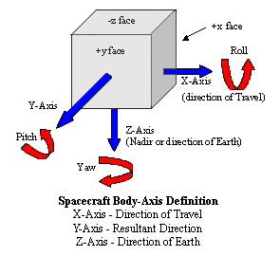Both CubeSats searching for emission of a 1550nm signal on all sides of the cube. If none are found, CubeSat 1 will start rotating on one axis. This will alternate between X, Y, and Z until any remnant of a signal is detected.

The various axis that the CubeSat must account for when correcting angular differences.

* Upon detection, intensity values are interpreted in both satellites and narrowing of angular difference between the two satellites begin.
  + CubeSat 1 will correct and rotate toward point of higher intensity.
  + CubeSat 2 will correct and rotate toward point of higher intensity.
* Feedback from this constant cycle helps both satellites remain independent from each other while allowing them to meet halfway in alignment.
* Once a certain threshold is met, the satellite with stop angular correction and attempt a communication link.

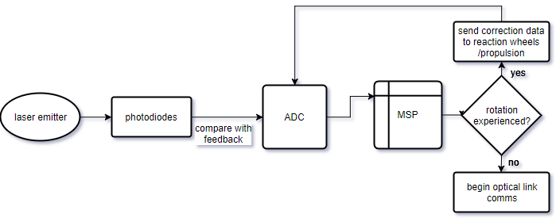

An example of the flow of data for input laser to the MSP.

## C:\Users\Volpone\AppData\Local\Microsoft\Windows\INetCache\Content.Word\SCHEMATIC.PNGArchitecture:

### Battery supply

#### Lithium Ion Battery - 850mAh

The sensor board is operated with a single independent battery pack that can be mounted onto the back of the sensor board. The benefit of having a battery pack is the ability to accept power from other modules in the CubeSat in the later future.

INPUT:

* 2-pin JST plug type battery input
  + Lithium ion battery (850mAh)

OUTPUT:

* Unregulated 3.7V signal
  + Decoupled with a capacitor across V_NOREG and universal GND

Battery includes built-in protection against overvoltage, overcurrent, and going under minimum voltage. The signal of V_NOREG passes through a power switch that can cut off power across the entire sensor board. When switched on, the positive voltage is sent across to a step-up voltage regulator. Additionally, the unregulated battery voltage is sent across a red LED to indicate that the board is powered on.

### Voltage regulator

#### Pololu Adjustable Step-Up/Step-Down Voltage Regulator S7V8A

An adjustable voltage regulator receives the 3.7V battery signal. The voltage is stepped up to a nominal 5V for operation of both the MCU and the serial communication interface.

INPUT:

* V_BATT+, the 3.7V supply from the battery

OUTPUT:

* Voltage regulated 5V signal

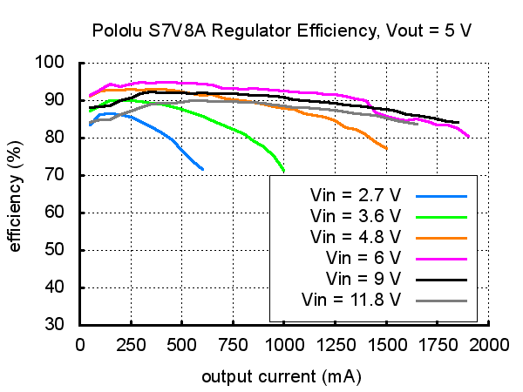The regulator features over-temperature and short-circuit protection. It can receive an input voltage anywhere from 2.7V to 11.8V. The output can be adjusted from 2.5V to 8V. Both the input and output voltages are decoupled to a universal GND in the event of a voltage surge.

A typical efficiency for the regulator is around 90%. This varies as current draw changes. To ensure efficiency stays as high as possible in future iterations, research must be done to better account for power usage.

### Microprocessor unit

#### ATMega328P, 8-bit AVR RISC

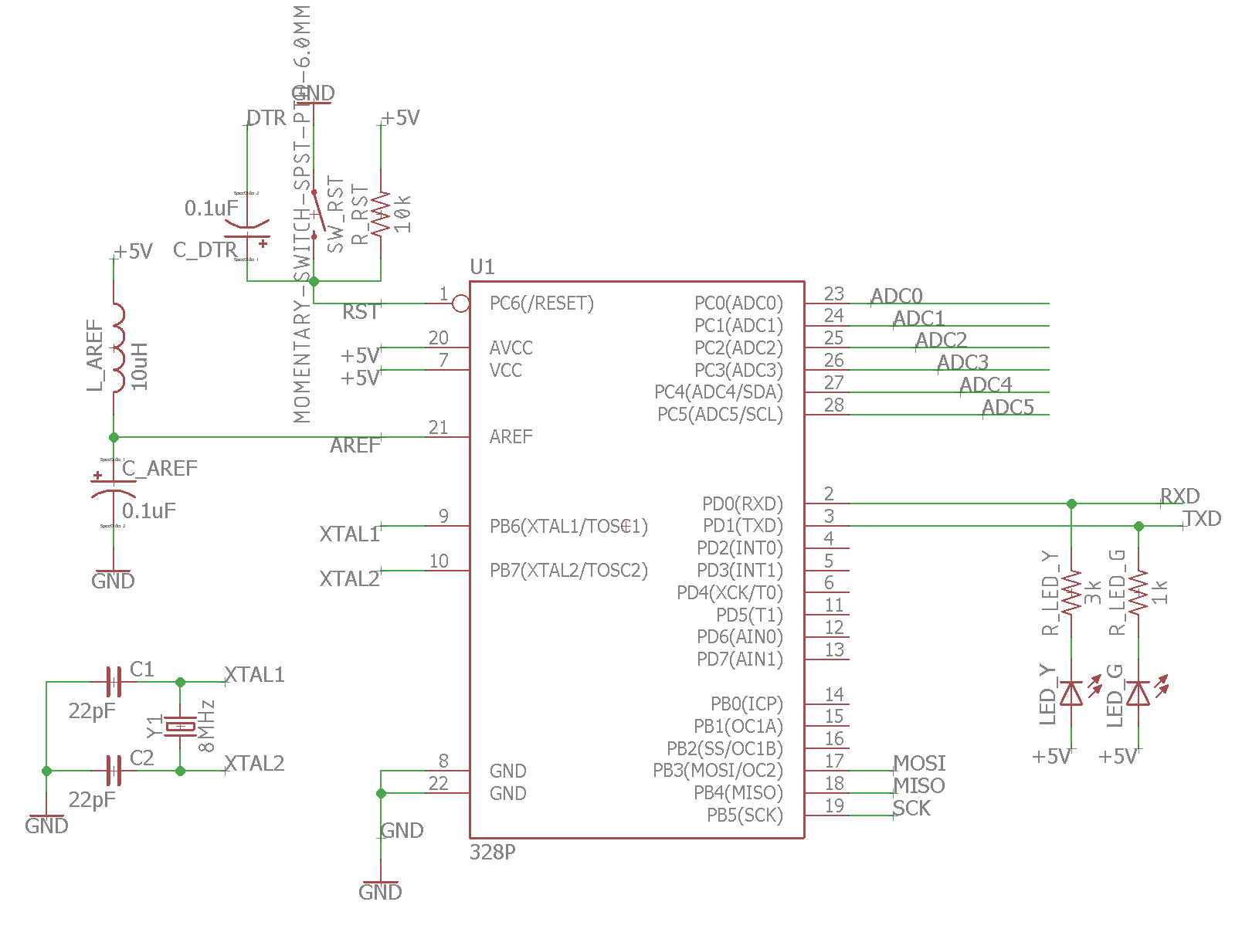

An adjustable voltage regulator receives the 3.7V battery signal. The voltage is stepped up to a nominal 5V for operation of both the MCU and the serial communication interface.

INPUT:

* +5V regulated power
* AREF used to establish a voltage reference for calculations
  + Uses +5V regulated power
* Push button reset
  + Inverse logic - pressing the reset button sets the RST pin to 0V
* ADC0 through ADC5 voltages
  + Signals from NIR photodiodes after their signal is amplified
* RX serial input
  + 76800 baud rate
  + Sent from a computer or another microcontroller, used to operate the debugging software for the sensor board

OUTPUT:

* TX serial output
  + 76800 baud rate
  + Received from a computer or another microcontroller, used to operate the debugging software for the sensor board

The ATMega328P is a low-power 8-bit RISC processor that handles the sensor data and provides a serial interface to monitor values on a computer. Currently, it only interfaces with this one sensor board, but future expansion can enable it to process data for many different facets of the CubeSat

### Photodiode sensor array

#### LM324N

Since the photodiodes are used in photovoltaic mode, voltage amplifier circuits are desired. LM324N is chosen as the op-amp used in the amplifier circuit because of its capability of single power supply. The non-inverting amplifier has a gain controlled by two resistors Rf and Rin. The photodiodes is able to output 200mV at max. Therefore, a gain of 15 is necessary if the amplified voltage is desirable in the range 0~3V. Rin is chosen as 1kΩ and Rf is chosen as 15kΩ.

INPUT:

* Photodiode voltage

OUTPUT:

* Amplified voltage between 0~3V

### Serial connectivity

*2x6 pinout male headers*

For the sake of convenience, two different 6-pin male headers were provided for compatible serial interface devices. These serial devices enables computers to monitor the data coming from the sensor board and permit the ability to interact with it.

INPUT:

* ODD numbered pins
  + FTDI cable 5V from SparkFun
* EVEN numbered pins
  + Pololu USB AVR Programmer v2
* In both cases, a computer can interact with the sensor board through serial input.

OUTPUT:

* Transmitted serial signal from sensor board

## Design

### PCB Version #1

80x80cm

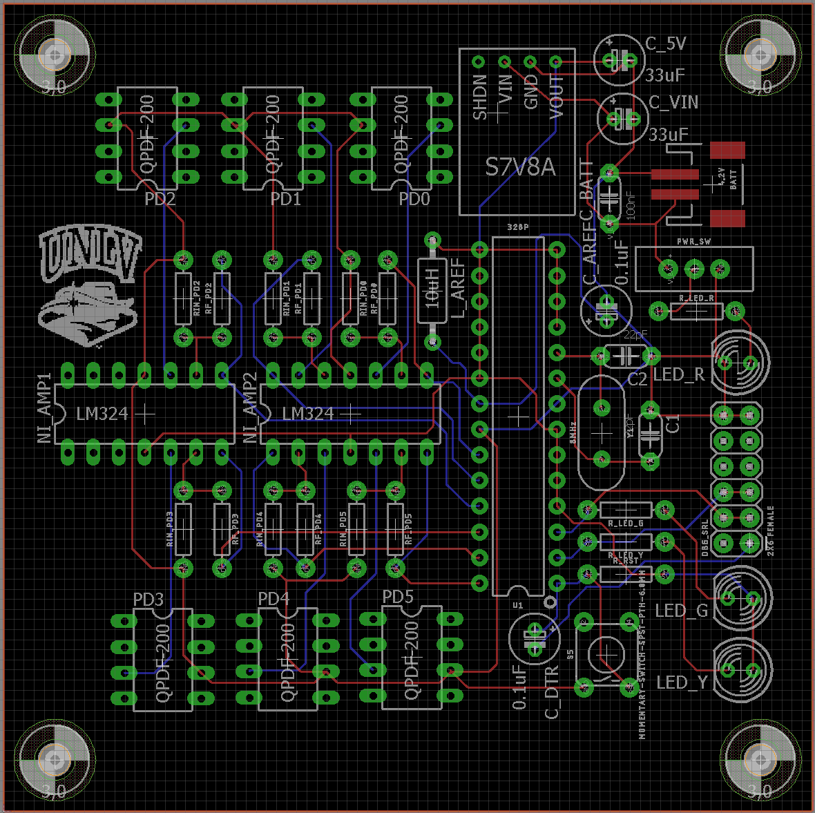

#### PCB Version #1 comments

The first printed circuit board (PCB) design featured all foundational components the project as listed above in architecture. All components were properly powered and connected serial interfaces could receive and transmit signals.

Complications that arose from this design were the following:

* Drill holes were too small for the S7V8A voltage regulator. As a result, it could not be soldered to the board.
* The battery connector was surface mount, however the purchased component from an internet vendor was a through-hole version.
* Poor grounding and unnecessary high-logic driven pins on the ATMega328P led to overheating issues. If left running for over 5 minutes, the chip would become too hot to touch.
* The power switch was not properly wired, so regardless if it was set to ON or OFF, the board still operated at full voltage.
* Orientation of the photodiode sensors were reversed, so their coupled fiber optic cable output faced into the board. This would cause cluttering if all six photodiodes were connected.
* Parts were not properly aligned along a 1mm grid.

### PCB Version #2

80x80cm

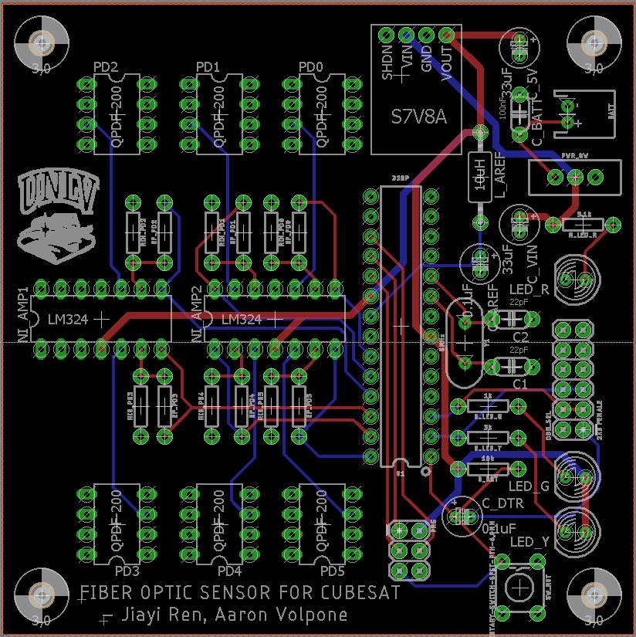

#### PCB Version #2 comments

The second PCB design fixed all complications that were found from the first printed iteration.

Minor additions that were included in the second board iteration:

* ISP programmer to allow on-board software to be flashed onto the MCU.
* Widened Vcc routing for the output of the voltage regulator traces.
* Included a ground plane, thereby removing the need to have ground traces scattered about the board.
* Names of project designers added to bottom of board.

### UART

#### Baud rate

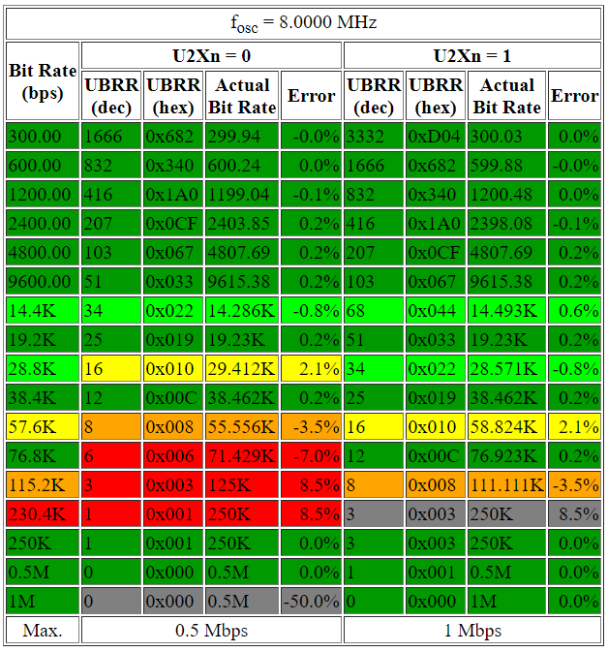Using an 8MHz crystal oscillator defines a narrowed number of different baud rate speeds for the ATMega328P. A baud rate is essentially the defined speed at which an MCU can transmit data (in bits) through a serial interface. Thus, the faster the baud rate, the quicker that data can be pushed out to a receiver. Fast data display is an important factor in being able to print large amount of data on a console.

List of available baud rates for an MCU running an 8MHz oscillator.

The table on the previous page shows a wide range of baud speeds for an equipped oscillator of 8MHz. To display the overview table on the front page of the running UART software, a high bit rate was chosen that was also not prone to a high error percentage. Since the U2Xn pin is set to 1 in the sensor software, the serial transmission can operate at double baud speed. Thus, a speed of 76800 baud was chosen since it is appropriately fast while still avoiding a high error rate.

## Simulation

### Amplifier

Op-amp voltage amplifier uses two resistors to control the gain of output voltage.

In this case, we used non-inverting amplifier because the photodiode is in photovoltaic mode. For simulation purpose, LT324 op-amp is used. Also, the photodiode is modeled as a voltage source with a capacitor. Rin is chosen as 1kΩ and Rf is chosen as 15kΩ. From the simulation, the output voltage is amplified to 3.2V.

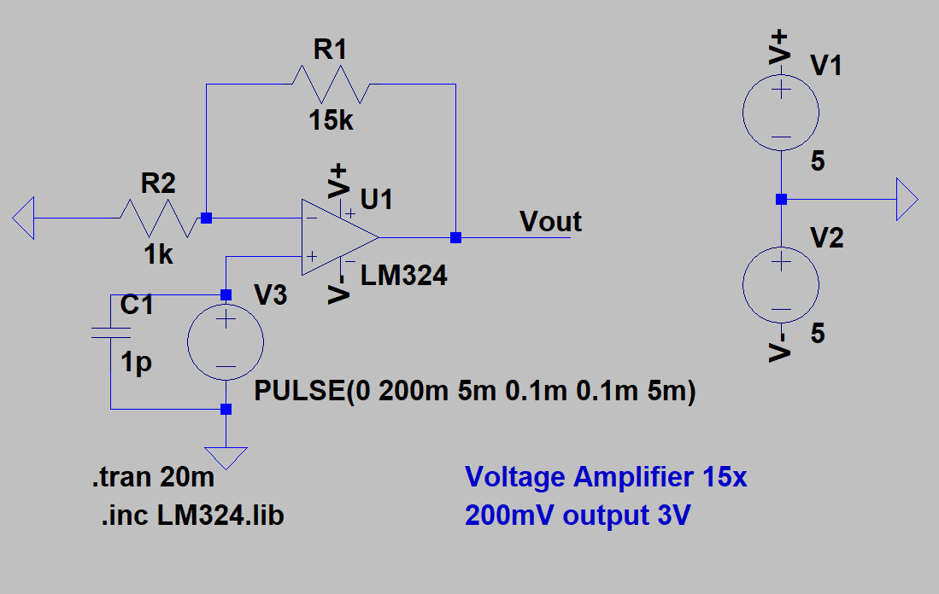

LTspice Circuitry

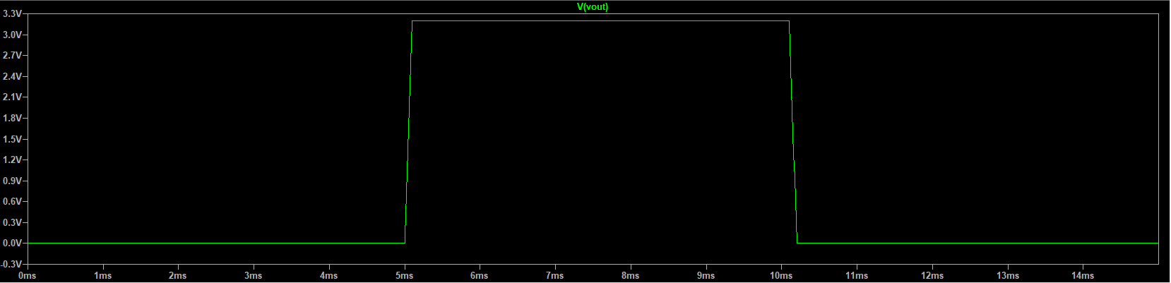

LTspice simulation

## Testing

### Hardware

All of hardware is specifically selected as DIP package so that it is convenient for testing purpose.

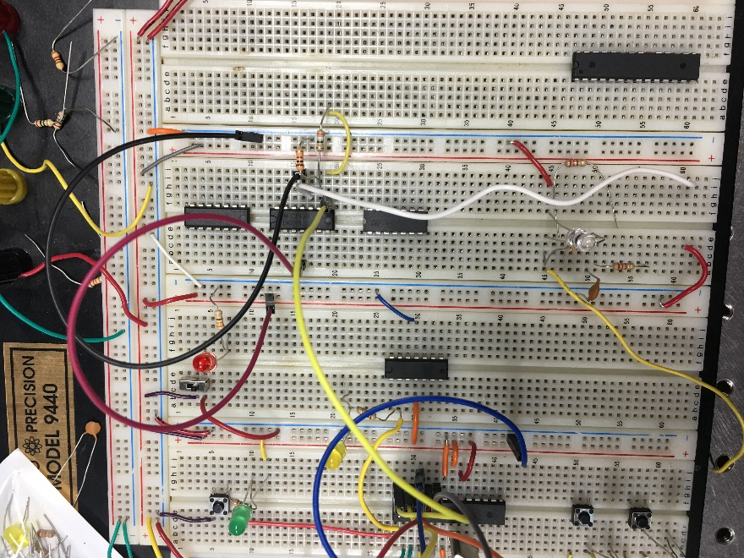

# User's manual

## How to Setup

1. Connect battery to the PCB battery port.
2. Connect laser diode fiber connector into the center fiber cable of 1-to-7 Fan-Out bundle.
3. Connect each photodiode to each individual fiber cable of the other six legs of 1-to-7 Fan-Out Bundle based on the number.
4. Connect the collimator to the single end of 1-to-7 Fan-Out Bundle.

## How to Connect

1. Use a USB cable to connect to a computer
2. Download latest version of PuTTY for data analysis
3. PuTTY setting, save:
   1. Host Name: COM3, port 76800

## User Instructions

1. Turn on the switch, both green led and red led should light up.
2. Turn on the laser diode driver, set the current limit to 65mA. Turn on the laser.
3. Open PuTTY. select the saved PuTTY setting.
4. Main menu is shown. Select the desired operation:
5. Overview mode – displays all sensor data along with a visualization of what the fiber is detecting.
6. Testbench mode – designed for sending data to a CubeSat test platform. If connected to another processor, it can give signals to test bench motors.
7. ADC debug mode – allows the operator to see the ADC channels changing in real-time to check calibration and operating status of the board.

# Roles & skills in the project

|  |  |  |
| --- | --- | --- |
|  | **Objects involved** | **Required skills** |
| **Microcontroller programmer** | * Software and test bench simulation | * C, C++ knowledge * Embedded systems understanding   Knowledge of Texas Instruments IDE for board development |
| **Analog to Digital Signal Processing** | * Conversion from amplifier to microprocessor | * Knowledge of image processing algorithms   Understanding of fiber optics engineering |
| **Amplifier** | * Voltage amplification | * Basic circuit design knowledge * Amplifier Operation knowledge |
| **PCB** | * PCB product | * Printed Circuit Board Design and Debugging knowledge * Soldering technique |
| **Fiber Optics** | * Optical test | * Basic knowledge of Optics * Knowledge of optical setup and calculation |

Table 3. Roles & skills

|  |  |
| --- | --- |
|  | **Assignment** |
| **Microcontroller programmer** | Aaron Volpone |
| **Analog to Digital Signal Processing** | Aaron Volpone |
| **Amplifier** | Jiayi Ren, Aaron Volpone |
| **PCB** | Jiayi Ren, Aaron Volpone |
| **Fiber Optics** | Jiayi Ren, Aaron Volpone |

Table 4. Roles assignment

# Parts list

### Laser emitter

#### QDFBLD-1550-2EM

The laser diode operates strictly in continuous-wave mode. That is, instead operating with a pulsed signal, the laser will stay in a perpetual “on” state. The forward operating voltage of this device is only 1.2V, so compatibility with the rest of the sensor’s items will stay within a reasonable low-wattage expectation. For use in the optics lab, the butterfly package that the laser is encompassed in will provide adequate accessibility to features such as integrated cooling and modes of operation.

Figure 2 - The emission spectrum of the laser. It is specifically designed to output an IR, 1550nm wave.

The laser outputs a solid 1550nm wavelength. This is beneficial in the application of fiber optic technology because it does not attenuate strongly – meaning that signal loss is negligible.

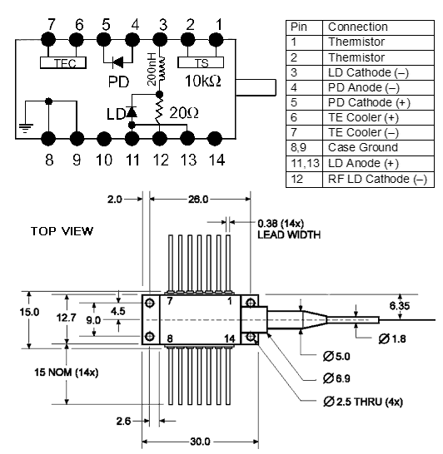

Figure 3 - The pin layout for the 2mW laser. The addition of the TEC cooling system is still not regarded as necessary at this point in the project.

### IR Photodiode (x6)

#### QPDF-200

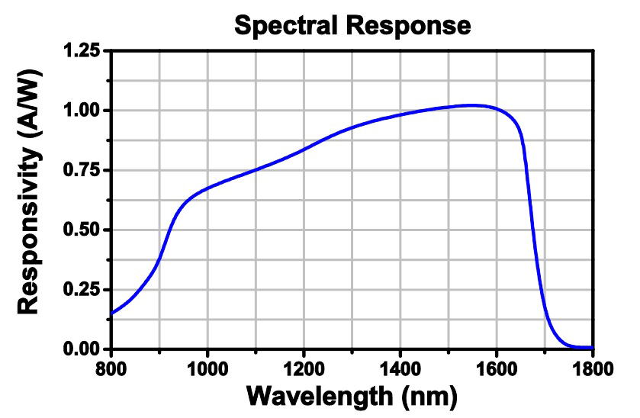

The spectral response of the photodiodes. These specific diodes are tailored to respond the best to 1550nm wavelengths.

The photodiodes are responsible for converting photons into an electrical signal. These will be reversed biased, so the positive and negative terminals will be oriented in reverse as shown in Figures 6 and 7. Currently, it is unknown what voltage will be used across all photodiodes. This is important to consider because the responsivity of the diodes will change depending on what voltage they are reverse biased as.

Depending on the output voltage, the photodiodes may need to be voltage amplified. This can be done with an op amp circuit. A figure of the dimensions and pin layout for the photodiode can be seen below.

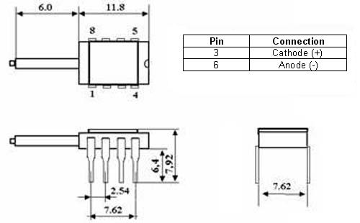

Figure 5 - The dimensions of the photodiode that is compatible with DIL socket applications.

### 1-to-7 Fan-Out Fiber Optic Bundles

#### BF74LS01

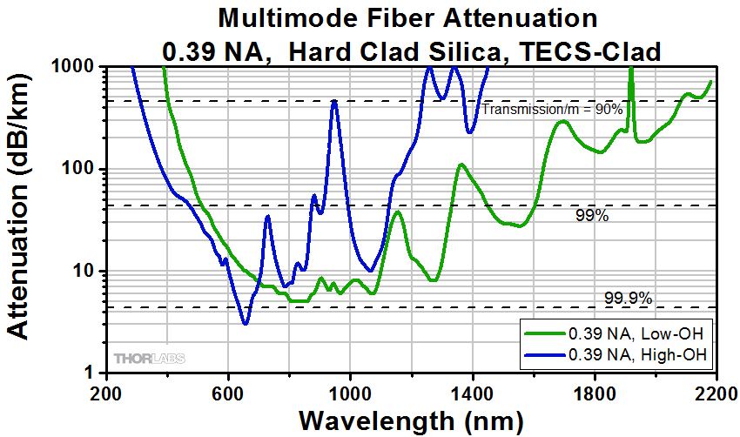

This 1-to-7 Fan-Out Fiber Optic Bundles has one multimode end and fans out into seven leges with a single fiber in each, which are arranged in a round configuration. The fibers has core diameter of 400 μm. The center fiber is connected with laser diode and other single fibers are connected with photodiodes.

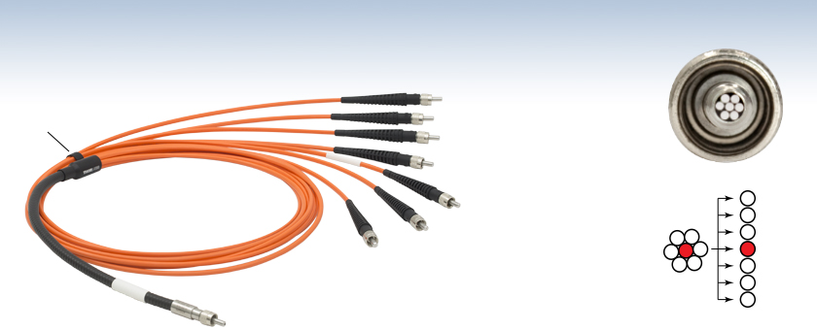

### Air-Spaced Doublet Collimators SMA

#### F810SMA-1550

This collimator is pre-aligned to collimate 1550nm laser beam from an SMA-connectorized fiber.

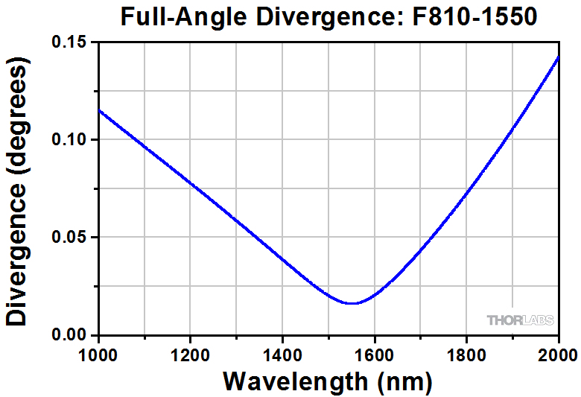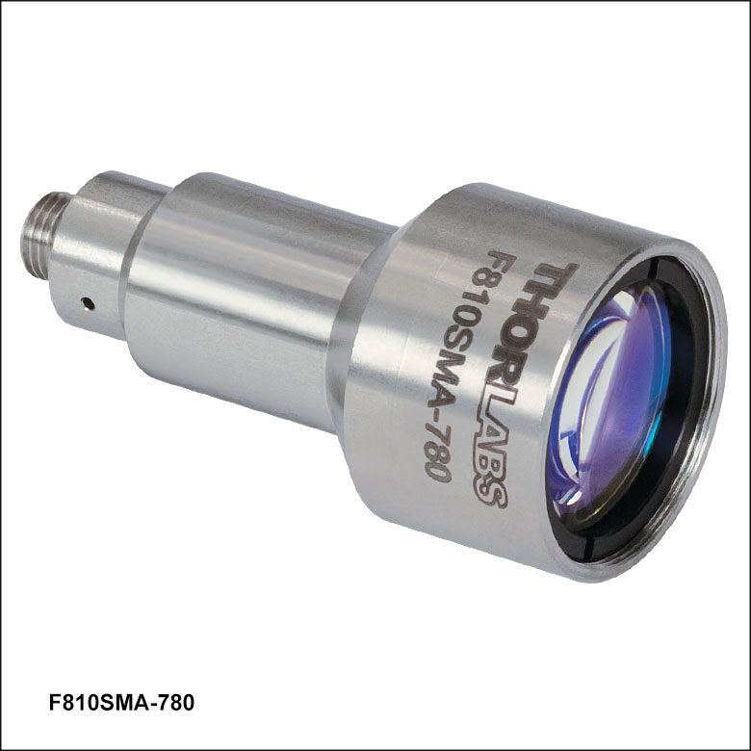

### Surface Mirror

#### Reflectivity of GoldME1-M01

This specific surface mirror is selected to ensure the efficiency of reflective light. The reflectance is average over 96% for light from 800 nm to 20 µm.

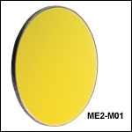

### Gimbal Mounts for Ø1in or Ø2in OpticsGimbal Mirror Mount

#### GM100

This mirror mount has a capability of angular rang of ±2.5°. It provides accurate angular positioning performance and is designed to hold Ø1" (Ø25.4 mm) optics. There are two adjustment knobs which are located on the top surface of the mount.

# 

# Project timeline

|  |  |
| --- | --- |
| **Week** | **Actions planned** |
| #3 (Jan.29-Feb.4) | * Complete amplifier design * Continued design of schematic * Continued work of ATMega328P ADC program * Test photodiode for min and max voltage values |
| #4 (Feb.5-Feb.11) | * Start PCB design * Non-PCB prototype testing * Test laser with mount * Test communication with microprocessor program on breadboard |
| #5 (Feb.12-Feb.18) | * Troubleshoot prototype problems on breadboard |
| #6 (Feb.19-Feb.25) | * Troubleshoot prototype problems on breadboard * Begin process of migration to PCB design |
| #7 (Feb.26-Mar.4) | * PCB design continuation * Part ordering for PCB |
| #8 (Mar.5-Mar.11) | * PCB routing and verification * Part ordering for PCB |
| #9 (Mar.12-Mar.18) | * Ordered first iteration of PCB design |
| #10 (Mar.19-Mar.25) | * First version of PCB arrives, troubleshooting * Second iteration prepared and ordered |
| #11 (Mar.26-Apr.1) | * Second version of PCB arrives, troubleshooting * PCB design operable – software development continues |
| #12 (Apr.2-Apr.8) | * Optical equipment research and ordering * Begin poster design |
| #13 (Apr.9-Apr.15) | * Final report drafting * Poster design work |
| #14 (Apr.16-Apr.22) | * Final report drafting * Poster design work * Setup optical equipment with parts that have arrived   + Complications in optical part compatibility have hindered progress in getting the demonstration to fully function. |
| #15 (Apr.23-Apr.29) | * Final report drafting * Submit poster for printing * Reordering of some optical equipment – await arrival |
| #16 (Apr.30-May.6) | * Receive poster board * Mock presentation with Dr. Greg * Present at Senior Design Competition * Submit final report and movie |

# Encountered Issues

## Hardware

### Phantom supply voltage

When connected to an external FTDI cable or TTL serial interface (such as a Pololu Programmer v1/v2), the sensor board will remain powered at a low voltage, even with the battery switched off. The recorded voltage running through the board’s Vcc is approximately 2.7V~3.0V. This is likely due to the intermittent voltage supplied by the RX and TX pins of the powered external interface. Because the phantom voltage can fall short of 3.3V, serial interfaces will fail to properly display proper ASCII characters, and may even brownout reset.

This will not an issue once the sensor board can be independently operated outside of serial communications.

To reproduce the phantom voltage, power off the sensor board while still being connected to a serial interface device.

### Minor ADC noise

A few precautions are taken to minimize noise throughout the sensor board. Firstly, the ADC channels are kept close to their input wires so that they didn’t travel far to encounter interference. Secondly, the AVcc pin is connected to the digital Vcc pin via an LC network. Lastly, the clock division factor is set to 256, thus the clock pre-scaler is as follows:

As the clock speed increases, so does the intermittent noise pick up from the ADC channels. Thus, a significant reduction in clock speed enables the ADC channels to operate with less switching interference.

Despite steps taken to reduce ADC noise, there is still an approximate 100mV deviation from measured values on a multimeter. This voltage offset is taken into account when displaying ADC and other voltage values from the microprocessor.

## Software

### Baud data rate complications

# Planned Improvements

* Integration with CubeSat testbench module with full autonomous operation. This includes mounting in a future designed CubeSat chassis.
* Reduction of sensor board surface area – switch to surface mounted parts.
* Reduction in number of photodiodes and replacement with smaller, more precise versions to save space.
* Reduction in fiber cable length to save space.
* Migration to a lower power, more precise microprocessor.
* Integration with other attitude sensors for more flexible angular control.

## Incomplete

### Laser Diode Driver PCB

The draft of Laser Diode Driver PCB is completed but yet to be manufactured. Breadboard testing is completed. The driver circuit consists of a 5V regulator circuit, adjustable current regulator, and a laser diode.

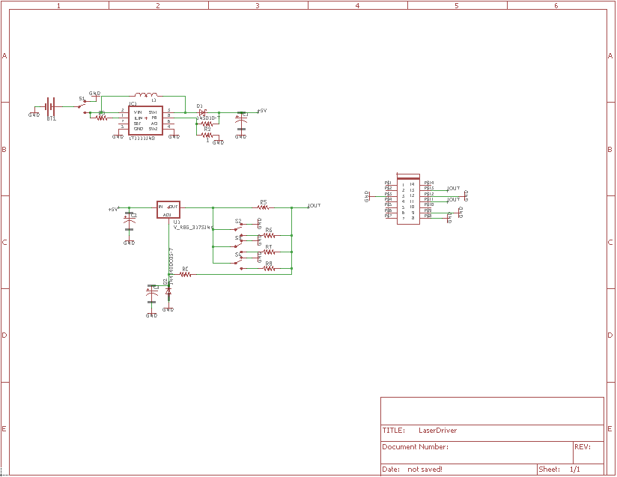

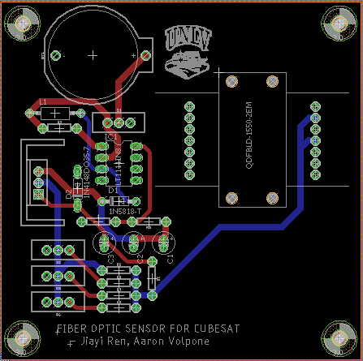

## Future work

The Fiber Optic Sensor for CubeSat is still very much in a preliminary stage. That means it must go through several revisions before being considered operational. Some improvements for the future include:

* Integration with CubeSat testbench module with full autonomous operation. This includes mounting in a future designed CubeSat chassis.
* Reduction of sensor board surface area – switch to surface mounted parts.
* Reduction in number of photodiodes and replacement with smaller, more precise versions to save space.
* Reduction in fiber cable length to save space.
* Migration to a lower power, more precise microprocessor.
* Integration with other attitude sensors for more flexible angular control.

### MCU Migration

Although the ATMega328P is affordable and easy to use MCU (microcontroller unit), it is not the most optimal microprocessor. What the ATMega328P lacks is high-resolution ADC precision, extremely low voltage and current operation (3.3V at 1mA or less), and larger bit registers. Several microprocessor replacements have been researched as early as Senior Design I for the intent of use in the near-future.

A Texas Instruments manufactured microprocessor was identified as a potential candidate to replace the ATMega328P, the MSP430F1612. The MSP430 is an actively produced MCU that sports several features that a low-powered satellite would benefit from. To name a few specifications of the controller:

* Low Supply-Voltage Range: 1.8 V to 3.6 V
* Ultralow Power Consumption
  + Active Mode: 330 µA at 1 MHz, 2.2 V
  + Standby Mode: 1.1 µA
  + Off Mode (RAM Retention): 0.2 µA
* Five Power-Saving Modes
* Wake-Up from Standby Mode in Less Than 6 µs
* 16-Bit RISC Architecture, 125-ns Instruction Cycle Time
* 12-Bit Analog-to-Digital (A/D) Converter
* With Internal Reference, Sample-and-Hold, and Autoscan Feature
* Dual 12-Bit Digital-to-Analog (D/A)

Additionally, the MSP430 provides 8 ADC channels for integrating even more sensors or other equipment for sensitive testing.

All modules already on-board the current iteration of the Fiber Optic Sensor for CubeSat can be successfully rerouted to operate with the MSP430 with some rerouting.

### Minimization

In future iterations of the fiber optic sensor PCB, it suggested that the use of surface mounted parts be used. This allows the overall surface area of the PCB to shrink, making room for other kinds of peripherals once mounted onto a CubeSat chassis. The addition of the MSP430 means that all parts (minus the photodiode DIL chips) could potentially be migrated to a smaller surface area board.

# Final Remarks

The Fiber Optic Sensor for CubeSat demonstrated a challenging relationship between the complexity of optical equipment and its price. Though the equipment present during this project can measure angular displacement, the size of its future implementation is not possible given the constraints of a CubeSat. Thus, several considerations need to be taken to reach a grander consolidation of equipment for the future of UNLV’s CubeSat project:

* Understanding of the relationship between minimization and growing costs. These need to be taken into account with the limited budget given with undergraduate senior design.
* Ensuring the continued multidisciplinary capabilities of future teams for projects. As CubeSat development continues, the facets of various member specializations begin to converge.
* Continuation of exposure to future students and the potential to carry these projects into graduate research.

The benefit of working through a long-term project is enabling the ability for future teams to pick up a on an established foundation.

# References

1. Sakamoto, et al. “Geometrical Parameter Analysis of the High Sensitivity Fiber Optic Angular Displacement Sensor.” [1502.03118] Geometrical Parameter Analysis of the High Sensitivity Fiber Optic Angular Displacement Sensor, 10 Feb. 2015, arxiv.org/abs/1502.03118.